HTML5 & CSS3
What is HTML and its uses?
HTML stands for HYPER TEXT MARKUP LANGUAGE, and is a markup language.
Hyper – stands for ANCHOR or HREF element
Example: <a href
Text – stands for the text in document.
MARKUP LANGUAGE – stands for the structure of document using elements like heading paragraph, link and more.
HTML is used to create User Interface components (collection of UI components).
HTML is a language used to create UI components, html will provide elements and each and every element provides some format called as tags with help of these creating UI components.
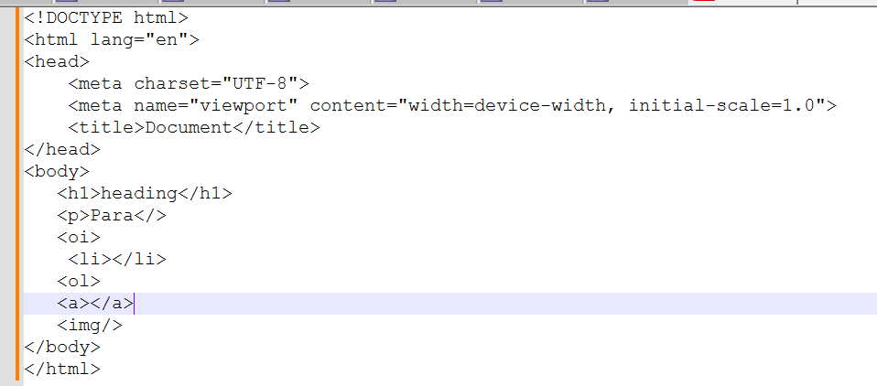
How does the HTML5 DOCTYPE declaration look and why is it simplified?
The HTML5 <!DOCTYPE html> declaration is simplified to just one line because HTML5 isn't based on SGML like previous versions. It’s designed to trigger standards mode in all modern browsers without the need for a complex DTD (Document Type Definition).
Element in HTML?
An HTML element is a component or building block of an HTML document, Elements will structure the HTML document.
An element is a part of a web page that is defined by a start tag, content, and an end tag. Elements can contain other elements, as well as text, images, videos, audio, and other types of content.
Tag in HTML?
Tag is a format of elements that structure the content on a web page. HTML tags are enclosed in angle brackets < >, and consist of two types: self-closing tag paired tag.
What are the new features introduced in HTML5?
Semantic elements: <nav>, <main>, <section>, <article>
Multimedia: <audio>, <video>
Graphics: <canvas>, <svg>
Form enhancements: <input type="date">, <input type="email">, placeholder, required
Local storage: localStorage, sessionStorage
Geolocation API
What is the difference between id and class?
id is unique; used once per page.
An **id** is unique and used to identify a single element on a page. It’s commonly used for scripting (JavaScript) or deep linking (#anchor)
class can be used multiple times; ideal for styling multiple elements.
A **class** is reusable and ideal for applying common styles to multiple elements.
In our UI project, we used class selectors for repeated components like cards, and ids for targeted JavaScript actions like modal triggers or scroll navigation.
What happens if you apply the same id to two elements?
It breaks the uniqueness rule. JavaScript’s getElementById() returns only the first match, and CSS behavior becomes unpredictable.
Explain the concept of semantic HTML. Why is it important?
Semantic HTML uses meaningful tags which clearly describe the content's role.
It improves accessibility and Search Engine Optimization, and helps developers understand structure better than using generic <div>
Semantic HTML elements like <article>, <main>, <nav>, <aside>, <header>, <footer>, and <section> give meaning to the content, rather than just structure.
<article> – self-contained content
<aside> – Sidebars, ads, notes
<nav> – navigation links
<main> – main document content
<header> – describes the page
<footer> – copy right details
<section> - Groups related content
What is the difference between <section>, <article>, <aside>, and <div>?
I use semantic tags like <section>, <article>, and <aside> to give structure and meaning to content, they help search engines and assistive technologies better understand the content which improves accessibility.
I use <div> only when I need a generic container for styling or layout, and there’s no semantic meaning.
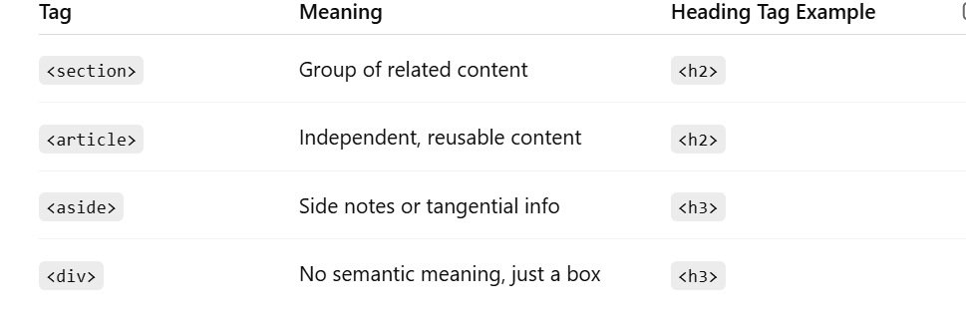
What is the difference between <section> and <article>?
<section> is used to group related content together under a common theme or heading. It helps organize the page into logical blocks.
<article> is used for self-contained, reusable content that can stand alone — like a blog post, news article, forum post, or user comment. It makes sense even outside the context of the page.
Where should <nav> be placed?
Typically inside <header> or directly under it. It represents a group of navigation links used for site navigation.
What does display: flex do on the <body> tag?
It makes the body a flex container, allowing us to center the form both horizontally and vertically using justify-content and align-items.
Why use flex-direction: column in the <form>?
By default, Flexbox arranges items in a row. We set flex-direction: column to stack the form fields vertically.
What are the key features introduced in HTML5 forms?
HTML5 introduced new input types (email, url, date, number, etc.), form validation attributes (required, min, max, pattern), and improved accessibility with label, placeholder, and autocomplete.
Input Type | Purpose
text | Single-line input
email | Validates email format
number | Numeric input
date | Date picker
password | Masked input
checkbox | Multiple selections
radio | One selection from options
submit | Form submit button
What are data- attributes? How and when should you use them?*
How do inline, block, and inline-block elements differ in HTML/CSS?
block elements take full width and start on a new line — useful for layouts.
inline elements flow with text but can't be resized.
inline-block gives the best of both — you can align inline and also control size.
I often use inline-block for buttons or cards inside flexible containers.
What is the Box Model in CSS? How does padding, margin, border, and content interact?
The Box Model in CSS describes how every HTML element is treated as a rectangular box that wraps around its content. It consists of:
Content: The actual text or image inside the element.
Padding: Space between the content and the border — it creates breathing room inside the element.
Border: The edge or outline of the element.
Margin: Space outside the border — it separates the element from others on the page.
|<-- margin -->|<-- border -->|<-- padding -->| content |
we used box-sizing: border-box to avoid layout shift issues. That way, padding and border stay within the defined width.
How does HTML5 handle offline storage? Compare localStorage vs sessionStorage vs cookies.
HTML5 introduced localStorage and sessionStorage as more efficient, client-side storage options compared to cookies. While localStorage stores data persistently, sessionStorage is limited to a tab session. Unlike cookies, neither are sent to the server automatically, reducing network load.
What is CSS and its uses?
CSS stands for Cascading Style Sheets, and it is a language used for styling and formatting HTML elements or UI components how it should display on web page.
Using CSS properties HTML elements will be styled up.
What does display: flex do on the <body> tag?
It makes the body a flex container, allowing us to center the form both horizontally and vertically using justify-content and align-items.
Why use flex-direction: column in the <form>?
By default, Flexbox arranges items in a row. We set flex-direction: column to stack the form fields vertically.
Align Radio Buttons and Checkboxes side by side using Flexbox?
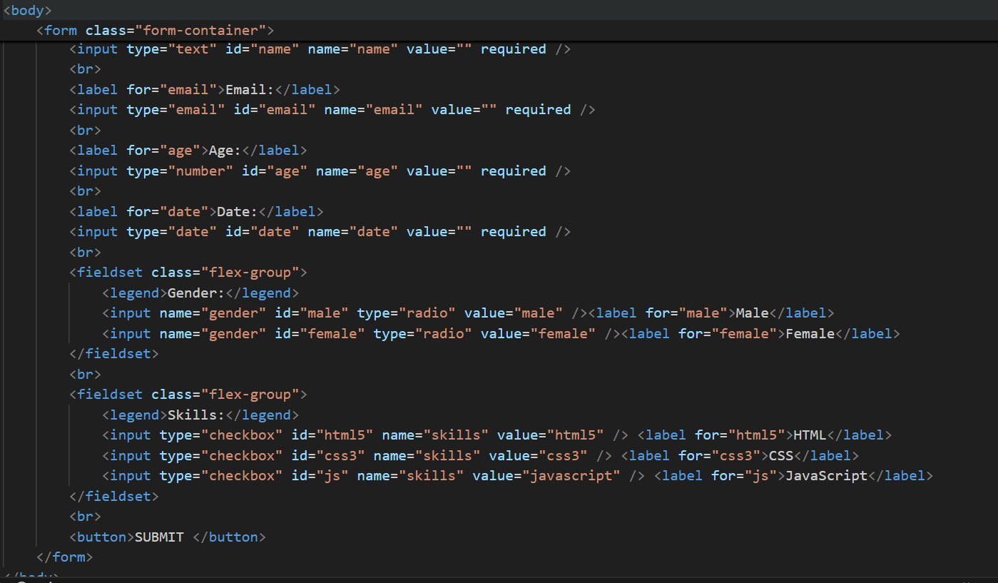
Why use Flexbox and Grid in CSS3?
Feature | Flexbox | Grid
Layout Type | One-dimensional (row OR column) | Two-dimensional (rows AND columns)
Best For | Aligning items in a row/column | Complex layouts with rows + columns
Alignment | Easy vertical & horizontal | Supports alignment too
Responsiveness | Very flexible with media queries | Great with auto-fit/auto-fill
Browser Support | Excellent | Excellent (modern browsers)

Why should we use Flexbox or Grid over floats or inline-block?
Flexbox and Grid simplify modern UI layout challenges. Flexbox excels at aligning items along one axis, while Grid is perfect for two-dimensional layouts. They improve responsiveness, readability, and reduce the need for complex CSS hacks.
When should you use Grid over Flexbox?
Use Grid when you need to control both rows and columns — like page layouts, dashboards, or image galleries. Flexbox is better for linear (row or column) alignments.
What’s the difference between relative, absolute, and fixed positioning in CSS?
relative shifts an element slightly from where it naturally appears.
absolute is positioned with respect to the nearest positioned ancestor. It’s useful for dropdowns or badges.
fixed is stuck to the viewport — perfect for sticky navigation or floating CTAs.
In our UI, I used absolute for tooltips inside cards and fixed for sticky filter panels on scroll.
Difference between em, rem, %, px in CSS?
I use rem for consistent scalable typography across the app, em for element-relative spacing, % for fluid layouts, and px only when precise control is needed.
In my Nokia project, we switched from px to rem for accessibility and responsiveness — especially for large-screen dashboards.
JAVASCRIPT
What is JavaScript and its purpose?
High level Programming interpreted language primarily used to create interactive and dynamic content on UI.
Purpose of JavaScript:
Client-Side Scripting: JavaScript is mainly used for client-side development, it runs in the user's web browser without the need for server-side processing.
DOM Manipulation: JavaScript can interact with the Document Object Model (DOM), enabling developers to modify the content and structure of web pages dynamically.
Event Handling: JavaScript allows developers to respond to user interactions such as clicks, key presses, or form submissions, making web pages more interactive.
Form Validation: JavaScript can validate user input in forms before submitting data to the server
Asynchronous Operations: JavaScript supports asynchronous programming through techniques like callbacks, promises, and async/await.
Web APIs Integration: JavaScript can interact with various web APIs (e.g., Geolocation API, Fetch API, Web Storage API) to enhance functionality, such as retrieving data from a server, storing data locally, or accessing the user’s location.
Cross-Platform Development: With environments like Node.js, JavaScript can also be used for server-side development, enabling the creation of full-stack applications. It's also used in mobile app development (e.g., React Native) and desktop applications (e.g., Electron).
Explain what kind of application we can built using Javascript.
variety of applications across different platforms.
Web Application
Mobile Application
Desktop Applications etc
What is .classList in JavaScript?
.classList is a JavaScript property used to access the list of CSS classes assigned to an HTML element. It provides methods to add, remove, toggle, or check classes on that element.
What are variables and explain the rules to create a variable?
Variables in JavaScript are used to store data that can be referenced and manipulated within a program.
Rules to follow while making use of variables
Variable name should contain only letter,digits,symbols($) and (_)underscore
First character must not be the digits
Variable Names should be in camelCase
What are Data types ?
Data types define the kind of data that can be stored and manipulated within a program.
Primitive Data Types:
Non-Primitive Data Types
Explain Primitive and Non-Primitive Data type.
JavaScript has 7 primitive types like.
Data Types: String, Number, Boolean, Undefined, Null, Symbol, BigInt which hold a single value and are immutable.
Non-Primitive(Reference) types like arrays and objects store more complex data structures and are passed by reference.
I often use typeof and Array.isArray() to safely check types before operations.
What is function in JavaScript
Reusable block of code designed to perform a specific task. Functions allow you to encapsulate logic and avoid code repetition
Explain the Difference between callback and higher order function in JS?
A callback function is a function that is passed as an argument to another function.
Callbacks are often used for asynchronous operations, like handling events, making API requests, or performing tasks after a delay.
callback function is executed after some operation has been completed.
A higher-order function is a function that either:
Takes one or more functions as arguments, or
Returns a function as its result.
What is difference between let , cons and var
In JavaScript, var, let, and const are used to declare variables, but they differ in terms of scope, hoisting, and reassignment.
🔹 Hoisting:
Hoisting is the mechanism where variable and function declarations are moved to the top of their nearest scope during the compilation phase.
If we try to access a variable declared with var before it's assigned, it will return undefined but won’t throw an error.
In contrast, accessing variables declared with let or const before initialization will throw a ReferenceError.
🔹 Scope:
var is function-scoped
let and const are block-scoped
🔹 Reassignment & Redeclaration:
var: Allows reassignment and redeclaration
let: Allows reassignment, but not redeclaration in the same scope
const: Neither reassignment nor redeclaration is allowed
In my projects, I avoid var completely. I use let for values that change (like counters), and const for everything else — especially functions and objects.
HOISTING:
Hoisting is JavaScript's behaviourw of moving variable and function declarations to the top of their scope during the compilation phase.
Only the declarations are hoisted — not the initializations.
Example
Var | Let | Const
console.log(a); | HOISTING will not support
var a = 10;
Internally var a;
console.log(a);
//nearest scope a = 10 ;
SCOPE/Memory var is a function level scope | let/const are block level scope { }
var supports redeclaration and Updation | let supports only Updation | with const no redeclaration /Updation, it must declare while initialize

- var is function-scoped and allows hoisting but is prone to bugs due to re-declaration.
- let is block-scoped and prevents re-declaration.
- const is also block-scoped, and its value cannot be reassigned. However, objects declared with const can still have their properties modified.
What is spread operator
Getting new array with the existing array values but not same array.
the spread operator is used to expand elements from an array or object into individual elements - useful when copying, merging, or passing values.
Expands values out
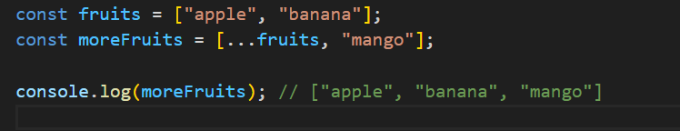

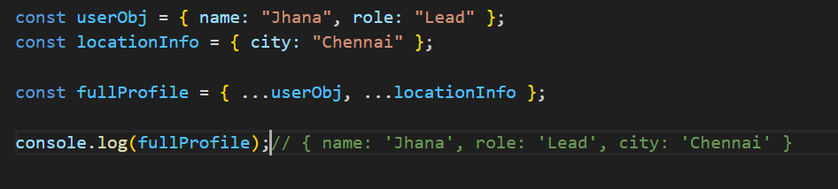

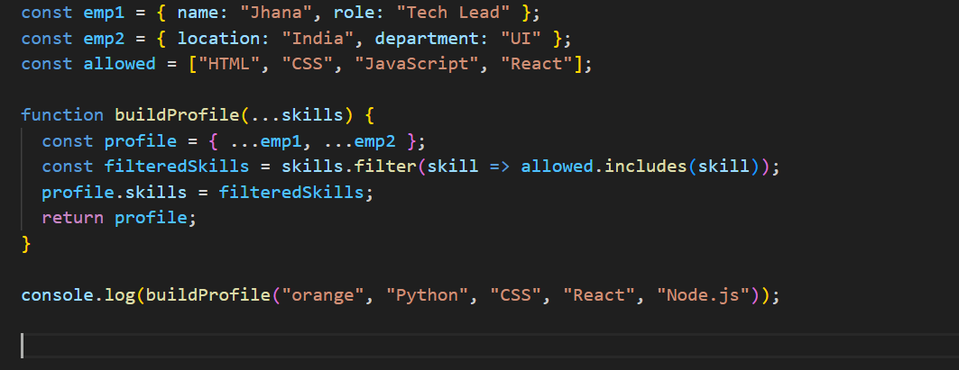
What is Rest Parameter
Rest parameter is used in function definitions to gather multiple arguments into an array, whereas
Gathers values into one
What is promise in Javascript
JavaScript Promises help manage asynchronous code by allowing us to handle success and failure in a structured way. They improve readability and avoid callback hell. Promises have three states: pending, fulfilled, and rejected
Methods:
.then(): Handles fulfillment and optionally rejection.
.catch(): Handles rejection.
.finally(): Runs regardless of fulfillment or rejection.
Advanced Methods: Promise.all(), Promise.race(), Promise.allSettled(), Promise.any().
Promise.all(), Promise.race(), Promise.allSettled(), Promise.any()
must-know for handling multiple promises in parallel
Promise.all():If any promise rejects → .catch() is triggered immediately, all async tasks must succeed before continuing
Promise.race(): Resolves or rejects as soon as the first promise settles (resolves OR rejects).
Fastest result wins, whether resolved or rejected.
Promise.allSettled(): Waits for all promises to settle (either resolve or reject). Always resolves with a summary of results. When you want to know the result of every promise, regardless of success/failure
Promise.any(): Only fails if all promises fail.
Explain different States of Promise in Javascript
• States: Pending, Fulfilled, Rejected.
How to create a Promise
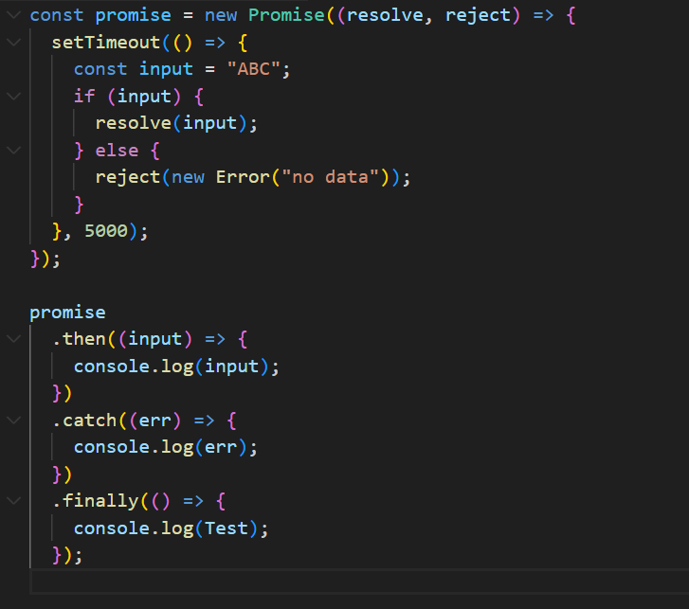
What is difference between promise and callback in Javascript
Callbacks: Functions passed to other functions to be executed later. Can lead to deeply nested code and complex error handling.
Promises: Objects that represent the completion of asynchronous operations. Provide better readability, chaining, and error handling.
Promises are generally preferred over callbacks for handling asynchronous operations due to their cleaner syntax, better error management, and improved composability.
What is Promise.all() in JavaScript, and how is it useful?
Promise.all() is a method that takes an array of Promises and returns a single Promise that:
Resolves when all of the input promises are resolved.
Rejects immediately if any one of the input promises is rejected.
"What is currying in JavaScript? How is it different from partial application? Show an example and a real-time use case where currying might be helpful?
Currying is the process of transforming a function with multiple arguments into a sequence of functions, each taking one argument at a time.
Breaks a function into a chain of functions, each taking one argument.
What is Callback
A callback is a function that is passed as an argument to another function to be "called back" at a later time(exception, deadlock, successful)
What is higher order function in Javascript
Higher-Order Function: A function that either accepts functions as arguments or returns a function.
Accepting Functions: Allows customization and flexibility by passing functions as arguments.
Returning Functions: Enables dynamic creation of functions with specialized behavior.
Higher-order functions enhance code modularity, readability, and reusability, making them an essential concept in modern JavaScript programming.
Explain different types of function in Javascript
functions are the building blocks
Allow not to repeat the code
Function Declaration and Function Expression
=> with function declaration calling is possible without declaration
=> with function expression calling is not possible without declaring it
What is arrow function in Javascript
Arrow functions are useful for creating short and readable functions, A concise way to write function expressions
Syntax: (parameters) => { body }
Arrow functions do not have their own this.
They inherit this from the lexical scope where they were defined (i.e., the surrounding context).
In this case, the arrow function is defined in the global scope, so this === window (in browser) or undefined (in strict mode / Node).
So, this.name is undefined.
Why we use call, apply bind method in
call: Invokes the function immediately with a specified this and arguments.
apply: Invokes the function immediately with a specified this and an array of arguments.
bind: Creates a new function with a specified this and optional pre-filled arguments, to be invoked later.
What is the array method , string method
In JavaScript, array and string methods are built-in functions that allow us to manipulate and process arrays and strings efficiently.
Array Methods
Used to perform operations like adding, removing, or transforming elements in an array.
Common examples:
map() – transforms each element
filter() – filters elements based on condition
reduce() – reduces the array to a single value
push() / pop() – add/remove from the end
includes() – checks if a value exists
“I commonly use map, filter, and reduce in React for rendering and data transformation.”
String Methods
Used for manipulating and analyzing text.
Common examples:
split() – converts a string to array
slice() – extracts part of a string
toUpperCase() / toLowerCase() – changes case
replace() – replaces part of a string
trim() – removes whitespace
“I often use trim() to clean input, and split() when handling CSV data or form values.”
What is the purpose of the array slice method?
What is the purpose of the array splice method?
What is the difference between slice and splice?
What is the difference between map and filter and reduce?
What are lambda expressions or arrow functions?
What is a first class function? Or What is a first order function?
What is a unary function?
What is the currying function?
What is a pure function?
What are the benefits of pure functions?
What is Null and undefined and NaN in javascript.
In JavaScript, both null and undefined represent the absence of a value
undefined is a primitive value that indicates that a variable has been declared but not yet assigned a value.
null is a primitive value that represents the intentional absence of any object value. a variable should have no value or that an object reference is empty.
in javascript null means "reference to non-existing object "
typeof null → "object"
typeof undefined → "undefined"
(typeof NaN); // "number"
NaN: "Not a Number" — result of invalid math operation
Why is type of null === "object"?
typeof null returns 'object' due to a legacy bug in JavaScript’s implementation. Although null is a primitive, it's incorrectly tagged as an object in memory. To truly check for null, we should use a strict comparison like value === null.
What are the possible ways to create Array in JavaScript?
1.let arr = [“a”,1,true,{name: jahna”}]
2.Let arr = new Array (“a”,1,true,{name: jahna”}
3.let arr = Array.of("a", 1, true, { name: "jahna" });
4.let arr = Array.from("hello"); // ['h', 'e', 'l', 'l', 'o']
5. let str = "hello";
let arr = [...str]; // ['h', 'e', 'l', 'l', 'o']
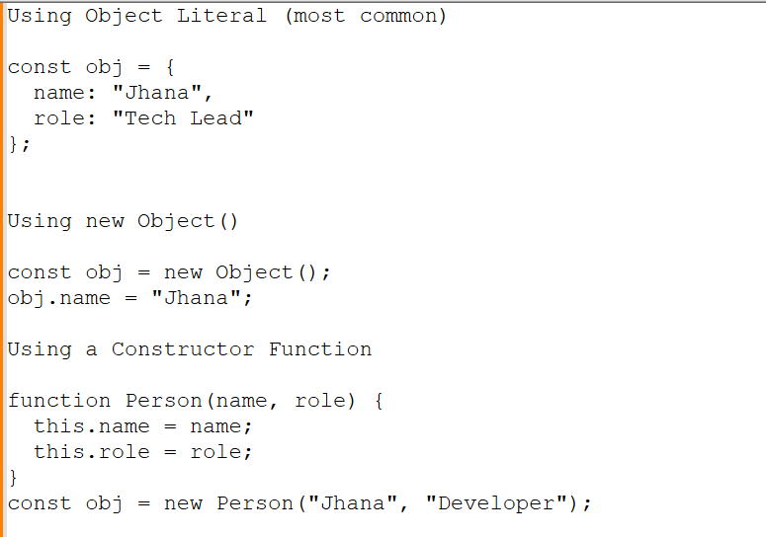
What are the different ways to clone an object Explain deep vs shallow copy?
Shallow Copy: Only copies the top-level properties. If a nested object exists, it still refers to the same memory so it's copied by reference.
Object.assign({}, obj)
Spread syntax: { ...obj }
array.slice() or array.from
let item = {
name: 'laptop',
price: 33000,
quantity: 1,
category: ['electronics', 'laptop']
dimensions: {
length: 7,
breadth: 3.5,
}
};
const spread = { ...item }; // Shallow copy
spread.quantity = 88; // Primitive value — copied safely
spread.dimensions.breadth = 22; // Nested object — shared reference!
spread.quantity is a primitive value, so it's copied by value.
spread.dimensions is a nested object, so it's copied by reference.
Deep Copy: it won’t disturb the original one.
JSON.parse(JSON.stringify())
structuredClone(obj) (modern, recommended)
Recursion or using libraries like lodash.cloneDeep
const deepClone = JSON.parse(JSON.stringify(item));
deepClone.dimensions.breadth = 99;
console.log('deepClone breadth', deepClone.dimensions.breadth); // 99
console.log('item breadth', item.dimensions.breadth); // 22 (unchanged)
How do you compare Object and Map ?
What is optional chaining?
What is the difference between map and forEach functions?
How to invoke an IIFE without any extra brackets?
What are truthy and falsy values?
Falsy values: false, 0, "", null, undefined, NaN
Everything else is truthy.
What is setTimeOut and setInterval in Javascript
setTimeout()
Purpose: Executes a function once after a specified delay.
setTimeout(() => {
// code to run once
}, 1000); // 1000ms = 1 second
setInterval()
Purpose: Executes a function repeatedly at fixed time intervals.
setInterval(() => {
// code to run repeatedly
}, 1000); // every 1 second
What are is map, filter , reducer in javascript?
They are powerful higher-order array methods introduced in ES5, commonly used for data transformation in a clean and functional way.
Map: Transforms each element and returns a new array.
filter(): Filters elements based on a condition and returns a new array.
Reducer: Reduces array to a single value by iterating and accumulating.
What is a prototype chain?
Lexical Scope (used by JavaScript)?
Lexical scope means a function can access variables or variable’s visibility from the scope where it was defined, not where it's called.
Inner functions access variables from their outer (parent) scopes.
What is closure in Javascript?
A closure is a function that remembers its lexical scope even when the function is executed outside that scope.
In simpler terms:
A function accessing variables from its parent (outer) function, even after the parent has finished executing.
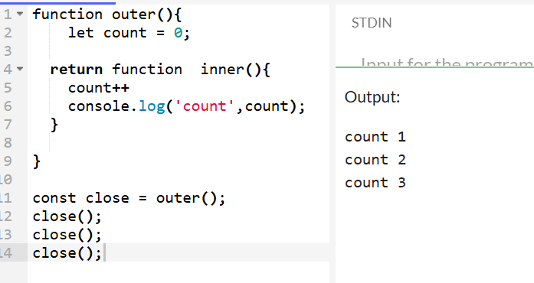
outer() has finished executing, the returned inner function still remembers count. That’s a closure.
What are the uses of closures?
What is the difference between array and object
Arrays and Objects are both used to store collections of data, but they differ in structure, purpose, and how you access their data.
Array
Stores ordered list of values.
Indexed using numeric keys (starting from 0).
Commonly used for lists, collections, sequences.
Has built-in methods like .map(), .filter(), .push(), etc.
Object
Stores unordered data as key-value pairs.
Keys are strings (or Symbols), not numbers.
Used to represent entities or structured data.
How to make an array empty?
By making the array length = 0; or assigning empty array;
Ler arr = [1,2,3,4]
arr.length = 0 or arr = [];
What is the difference between number type and BigInt type
Both Number and BigInt are used to represent numeric values, but they differ in size limits and precision.
What is this in JavaScript? Or
Explain "this" in different contexts (regular function, arrow function, method, setTimeout, etc.)
this keyword refers to the context in which a function is called — not necessarily where it was defined.
Its value is dynamic and depends on how the function is invoked, not where it's written.
In a regular function, this refers to the object that calls the function — it’s dynamically scoped.
In an arrow function, this is lexically scoped — it does not have its own this. Instead, it inherits this from the surrounding (outer) scope where the function was defined, not where it is called.
What is the difference between call(),apply() and bind()
Both call() and apply() are used to invoke a function with a specific this context. The only difference is how arguments are passed.
Call(): Invokes a function immediately, with a specified this and arguments passed individually.
func.call(thisArg, arg1, arg2, ...);
apply():Same as call(), but arguments are passed as an array. (or array-like object).
func.apply(thisArg, [arg1, arg2, ...]);
bind()
Does NOT invoke the function immediately.
Returns a new function with this permanently bound.
Used for delayed or reusable function execution.
const boundFunc = func.bind(thisArg, arg1, arg2);
boundFunc(); // later
The call(), apply(), and bind() methods allow you to control the value of this inside a function. call() and apply() execute the function immediately with arguments passed either individually or as an array. bind() returns a new function with this bound, ideal for delayed execution or event binding.
What is JSON and Its Common Operations?
JSON (JavaScript Object Notation) is a lightweight data-interchange format used to store and transport data. It is:
Easy to read and write for humans
Easy to parse and generate for machines
Language-independent (though based on JavaScript syntax)
JSON is commonly used in:
APIs (sending/receiving data)
Config files
Storing structured data (e.g., localStorage)
What is DOM and DOM Manipulation.?
DOM
The Document Object Model (DOM) is a programming interface that represents the structure of HTML and XML documents. It allows JavaScript to access and manipulate the content and structure of a webpage.
DOM Manipulation
JavaScript can interact with the Document Object Model (DOM), enabling developers to modify the content and structure of web pages dynamically.
How to create element dynamically using Javascript
can use document.createElement() to create a new HTML element and append() to insert it into the DOM."
Explain Closures in Javascript ?
Closures are functions that have access to variables from an outer function, even after the outer function has finished executing. They encapsulate data and provide a way to maintain state between function calls.
Explain different Scopes in Javascript:
Function level
Any variables, functions or class is declared under a block
Global level:
Any variables, functions or class is not declared under any block
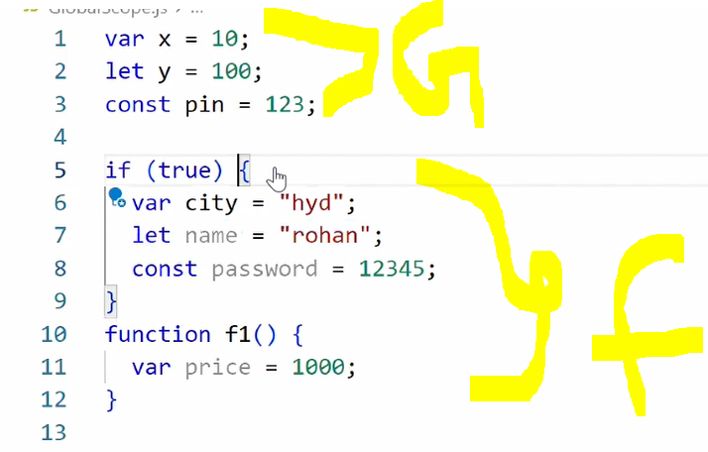
Module level:
Area across your application is considered as a module scope.
Any variables, functions or class is accessible from one file to another file using Named export and default Export.
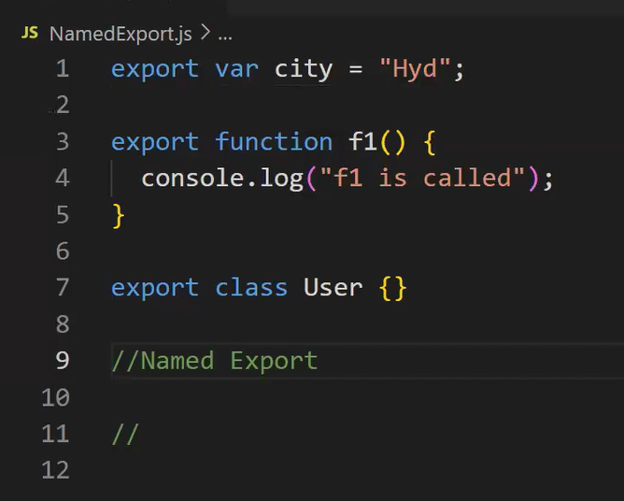
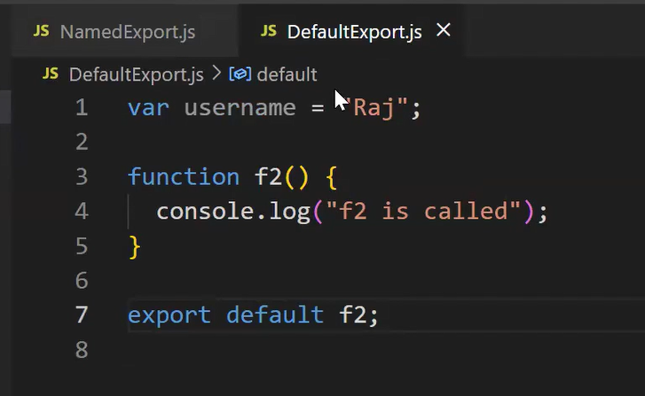
What is import and export?
The import and export keywords are used in JavaScript ES6 modules to share code between files — making code modular, reusable, and easier to maintain.
What is Destructing in the Javascript
Destructuring is a feature in JavaScript that lets you unpack values from arrays or properties from objects into individual variables in a clean and readable way.
Destructuring makes your code cleaner and more readable by directly extracting values from arrays or objects. It’s especially useful in modern JavaScript, React, and API response handling.
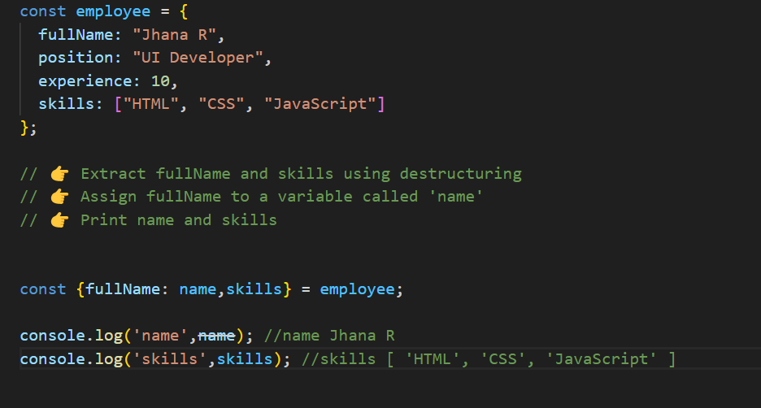
Difference between Normal Function and Arrow Function
A regular function has its own this context, which is dynamically bound based on how the function is called. It also supports hoisting, can access the arguments object, and can be used as a constructor with new.
On the other hand, an arrow function is more concise and inherits this from its enclosing (lexical) scope. It doesn’t support hoisting, doesn’t have its own this or arguments, and cannot be used as a constructor.
Syntax
Regular: function greet() { }
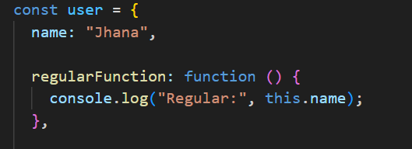
When you call it like user.regularFunction(), the this refers to the user object
So: this.name → "Jhana"
Arrow: const greet = () => { }
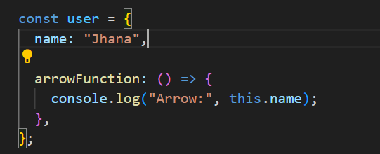
Arrow functions do not have their own this
So: this.name → undefined
Hoisting
Regular functions are hoisted — you can call them before their definition.
Arrow functions are not hoisted — you must define them before using them.
Explain difference between map() and forEach()
Use map() when you need to create a new array by applying a transformation to each element of the original array.
Use forEach() when you need to execute a function for each element of the array without modifying or creating a new array.
map() and forEach() are both methods used to iterate over arrays
forEach | Map
Does not return a new array | Returns a new array with the transformed elements
Since forEach() returns undefined, it cannot be chained with other array methods. | Since map() returns a new array, it can be chained with other array methods like filter(), reduce(), etc.

What are events in Javascript.
Events are actions or occurrences that happen in the browser, can respond to these events by executing code in response.
Mouse Events
Keyboard Events
Form Events etc..
Can you explain how JavaScript handles asynchronous operations and how the event loop works in detail? Give a real-world example.
JavaScript is single-threaded—it has one call stack and executes one command at a time. But it's designed to be non-blocking, which it achieves using the event loop in coordination with the Web APIs, callback queue, and microtask queue.
The Event Loop is a fundamental part of JavaScript’s runtime. It allows non-blocking, asynchronous operations (like setTimeout, Promises, and API calls) to execute without stopping the main thread.
Event Loop – How it Works:
Call Stack: Executes all synchronous code line-by-line.
Web APIs: When we call setTimeout, fetch, or DOM events, they are offloaded to browser Web APIs.
Callback Queue (Macrotask Queue): Once the async operation completes, the callback is placed in the queue.
Microtask Queue: Promises and queueMicrotask() callbacks go here (higher priority than callback queue).
Event Loop: Constantly checks if the call stack is empty. If empty:
  - First it processes all microtasks
  - Then it processes one macrotask from the callback queue
JS Code → Call Stack
↓
If async (setTimeout, fetch) → Sent to Web APIs
↓
Web API done? → Place callback into:
↳ Microtask Queue (Promises, async/await)
↳ Macrotask Queue (setTimeout, events)

Event Loop:
If Call Stack is empty:
→ Run ALL microtasks
→ Then run ONE macrotask

Explain the difference between == and ====

Loose Equality Operator == Performs type coercion
Example: 2 == "2" results true
Strict Equality Operator === it doesn't support coercion (Checks both type and value)
Example: 2 === "2" results false
What is an anonymous function in JavaScript?
An anonymous function is a function without a name. It can be assigned to a variable or passed as an argument to another function. They are often used for onetime or callback functions.
What is the purpose of the filter() function in JavaScript?
The filter() function is used to create a new array containing elements that pass a certain condition defined by a provided function. It allows filtering elements from an array based on specific criteria.
What is the purpose of the reduce() function in JavaScript?
The reduce() function is used to reduce an array to a single value by applying a function to each element and accumulating
What is the difference between function declarations and function expressions in JavaScript?
Function declarations are hoisted and can be called before they are defined, while function expressions are not hoisted and must be defined before they are called.
How do you manage asynchronous operations in large-scale JavaScript apps?
I use Promises and async/await for readable async logic. For large-scale apps:
- I organize API calls in separate services/modules.
- I use error boundaries and global error handling.
What design patterns do you commonly use in JavaScript projects?
- Module Pattern: To encapsulate and organize code.
- Observer Pattern: For event-driven architecture or pub/sub systems.
- Factory Pattern: For object creation with dynamic behavior.
- Singleton Pattern: For managing global state like auth/session.
- I also follow SOLID principles in my component and service design.
Explain the JavaScript Event Loop in detail, including the roles of the Call Stack, Heap, Web APIs, Callback Queue (Task Queue), and Microtask Queue. How does this mechanism enable JavaScript's non-blocking, asynchronous behavior, and what are common pitfalls related to it?
methods
Why this is a good lead-level problem:
- Tests understanding of array methods, object manipulation, and clean code.
- Can discuss scalability, immutability, and error handling enhancements.
- Opens up for optimizations using Map, if needed.
Double the values in an array.
To act upon each element of array and forms or returns a new array using map()
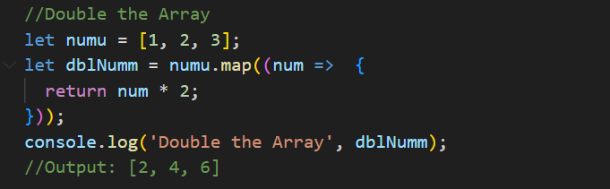
OR
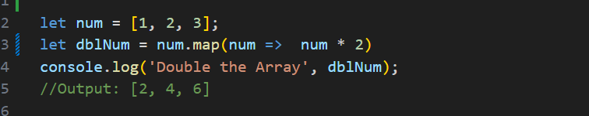
SPLICE and SLICE
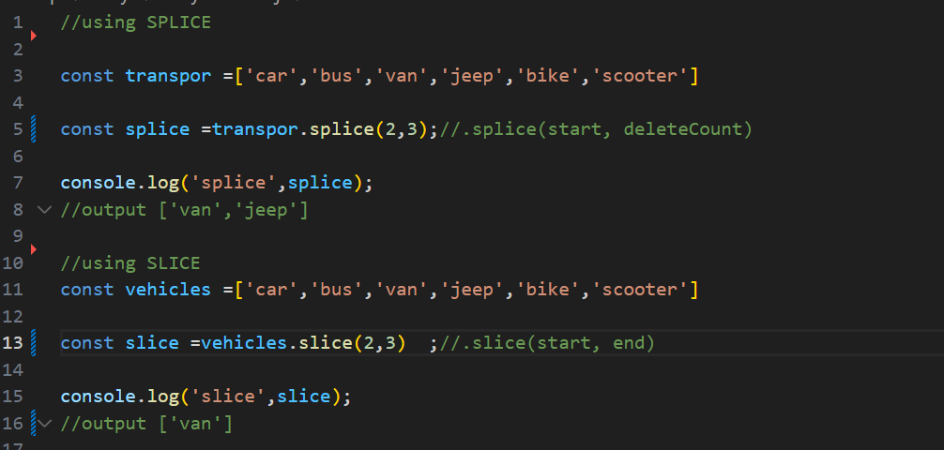
Filter out odd numbers or even numbers
Returns a new array with elements that match a condition
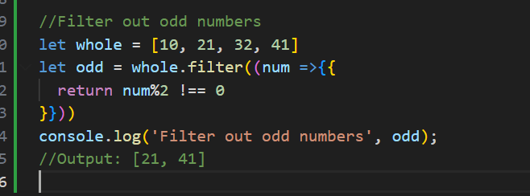
OR
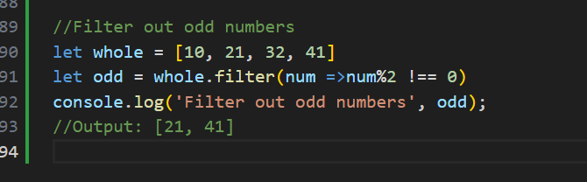
Check even and odd
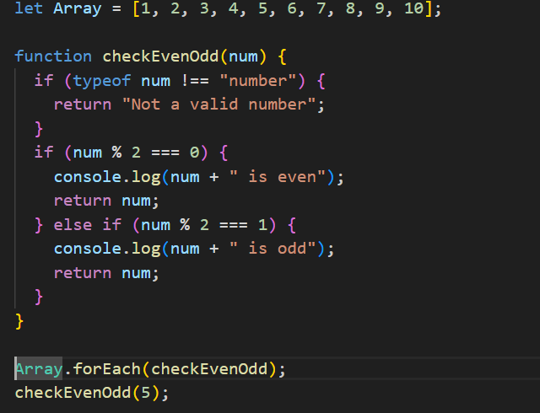
Find the largest/maximum number from a given array of numbers.
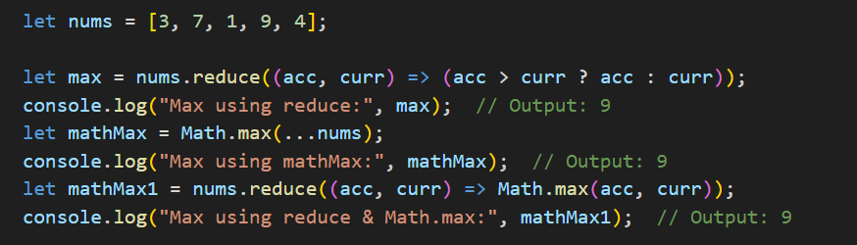
With loop function
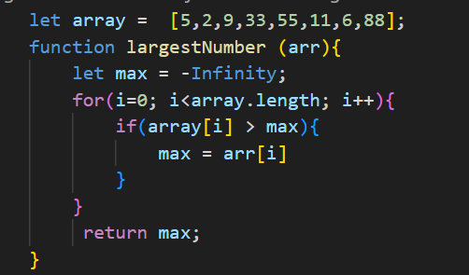
Find the second largest/second max number from array of numbers.
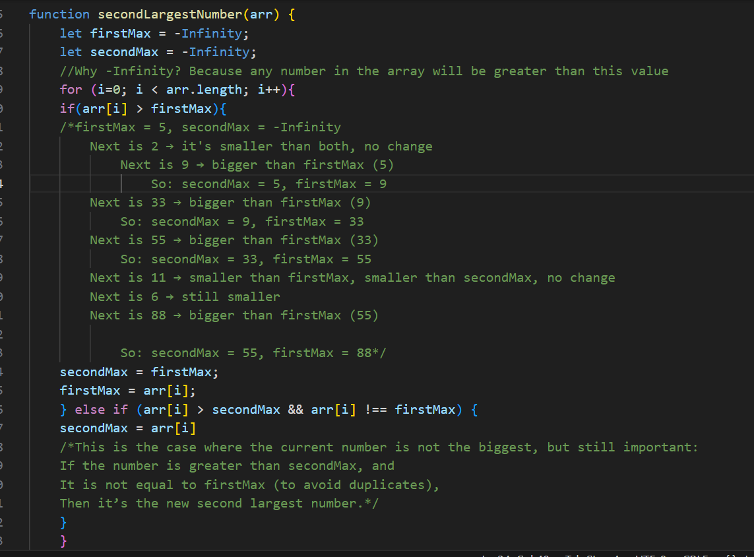
Find the first number greater than 50
Using find method we can achieve.
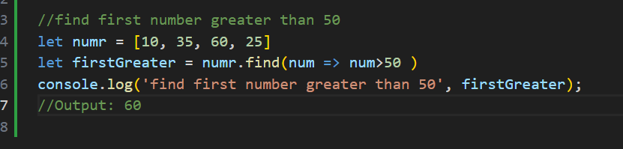

Sum all numbers in the array
array.reduce((accumulator, currentValue) => { ... }, initialValue);
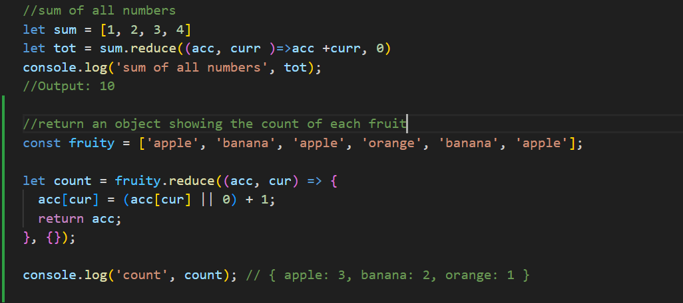
Remove duplicates from an array
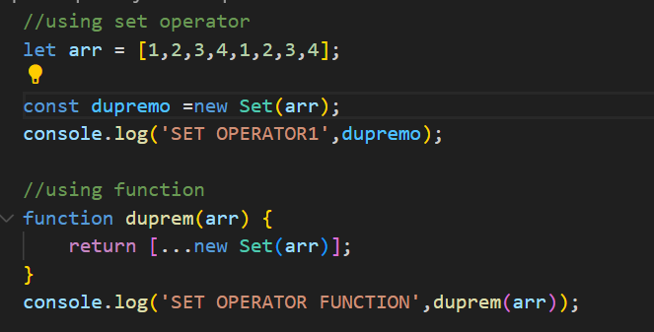
Flatten a nested array
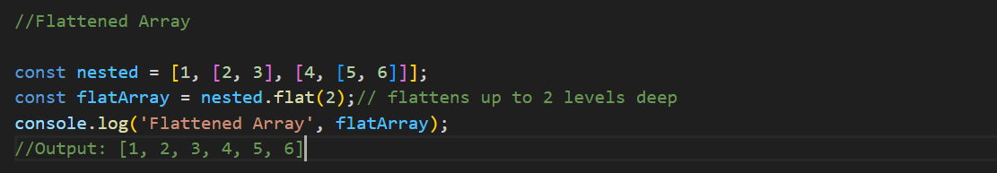
Convert an array to a comma-separated string
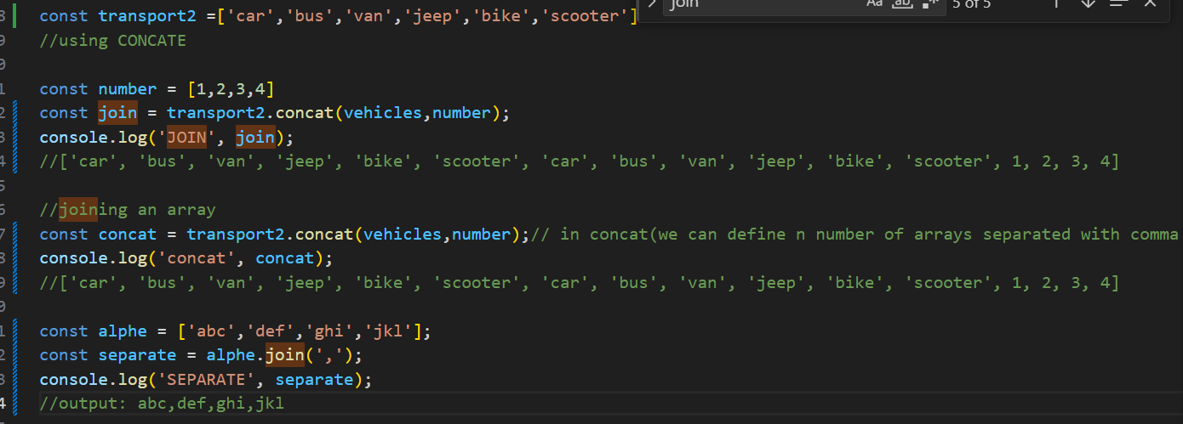
Sort numbers in Ascending/Descending order
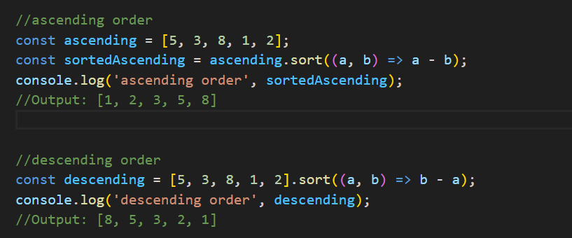
Get names of users who are older than 30 in uppercase.
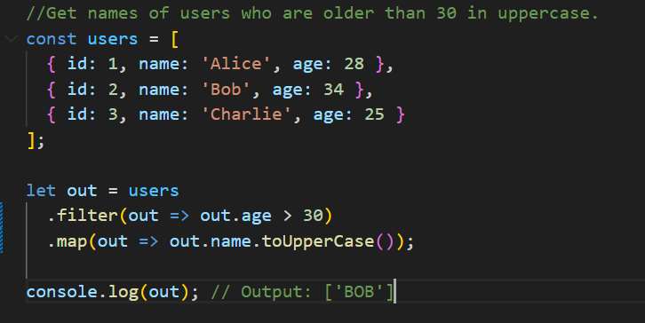
Find the first user who is younger than 30.
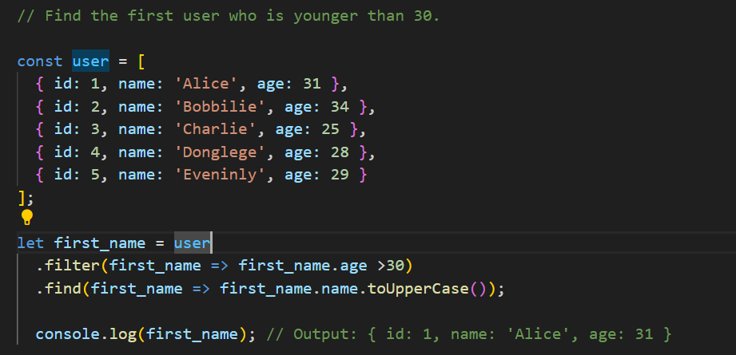
Double the values in an array
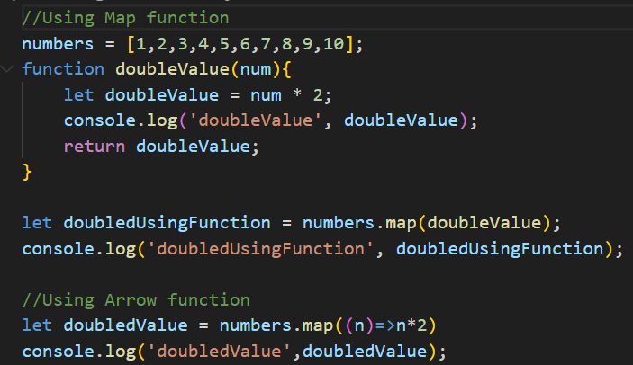
Group an array of objects by a specific property
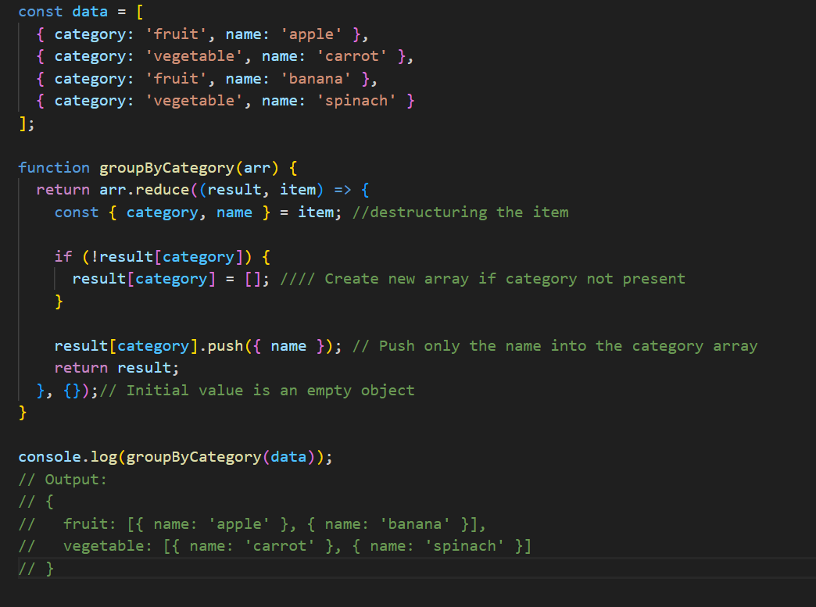

event listener
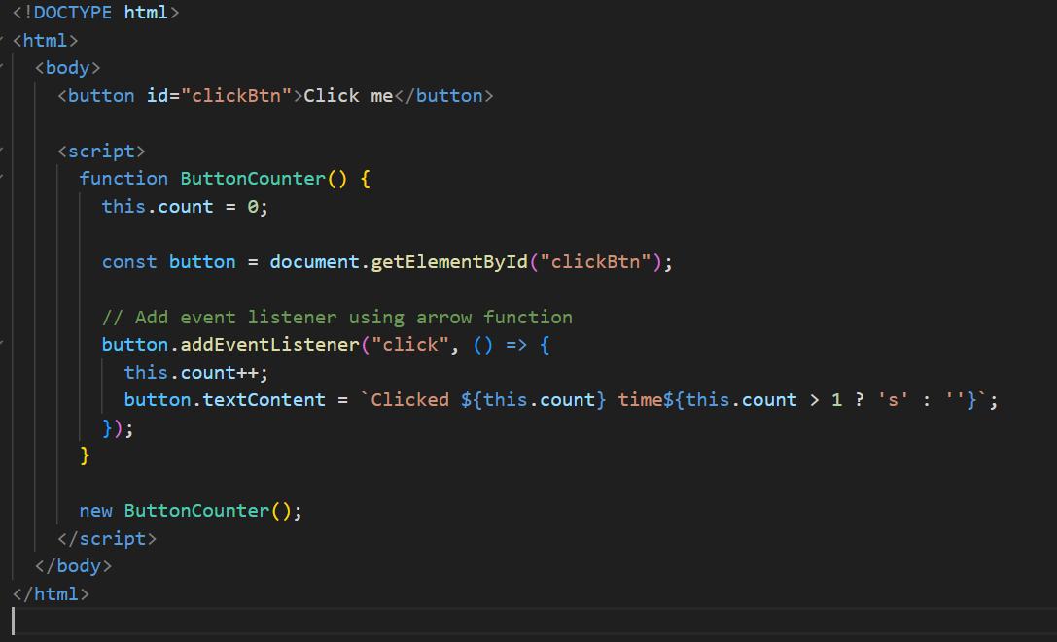
DataTypes
What's the difference between == and === in JavaScript?
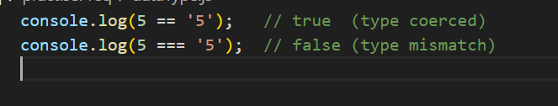
== checks for value equality with type coercion, whereas === checks for both value and type without coercion. For clean, predictable comparisons, prefer ===.
What do you think the output is for:
First
console.log(a); // undefined
var a = 10;
console.log(b); // ReferenceError: Cannot access 'b' before initialization
let b = 20;

NEXT
[] == false //true
[] === false //false
typeof [] is "object" and typeof false is "boolean"
[] == false is true because JavaScript performs type coercion: an empty array converts to an empty string, which becomes false. But [] === false is false because their types differ — object vs boolean.
NEXT
console.log(NaN === NaN); // false
console.log(Object.is(NaN, NaN)); // true
in JavaScript, NaN is not equal to itself with ===, which can be confusing. Object.is() is introduced to correctly compare edge cases like NaN === NaN, and also distinguish +0 and -0.
NEXT
console.log({} == {}); // ? false because creates a new object in memory.
console.log([] == []); // false because creates a new array in memory.
console.log([1] == [1]); // false because creates a new array with one element 1

NEXT
console.log({} + {}); // [object Object][object Object]
console.log([] + []); // empty string
console.log([1] + [1]); // "11"
console.log([] + {}); // [object Object]
console.log({} + []); // 0

NEXT
console.log(0.1 + 0.2 === 0.3); // false
Due to floating-point precision issues, the result of 0.1 + 0.2 is:
To fix Number((0.1 + 0.2).toFixed(2)) === 0.3 // true
NEXT
function test() {
console.log(a);//undefined due to hoisting.
var a = 10;
}
test();

NEXT
!!"false" and !!"true" "false" and "true" are both non-empty strings. •
Any non-empty string in JavaScript is considered truthy.
NEXT
true && "Hello" // "Hello" and operand so it return second value bcz 1st truthy
false && "Hello" // false
false || "Hi" // "Hi" or operand so it will return true or first value
"Hello" || "Hi" // "Hello" or operand so it will return true or first value
!true // false
!0 // true (0 is falsy)

breakdown
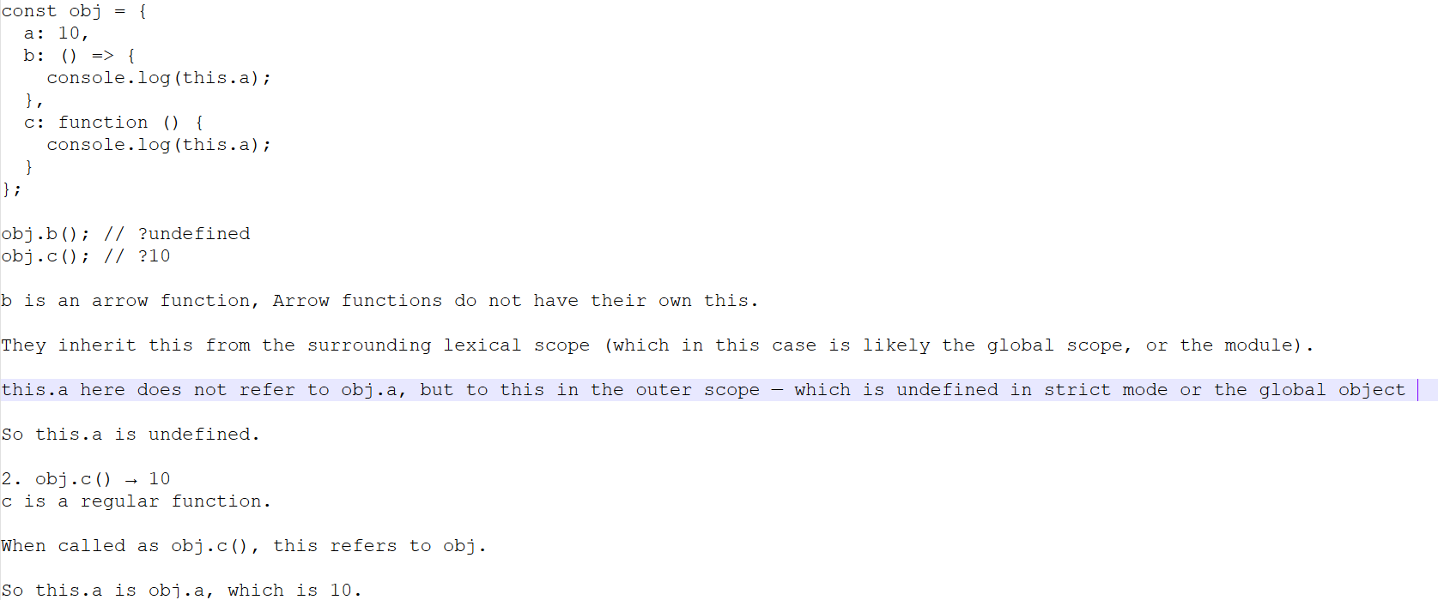
NEXT
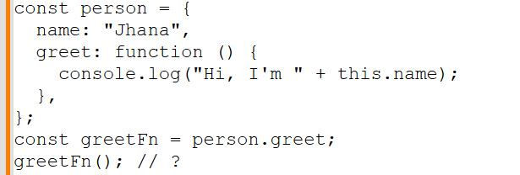
Answer:
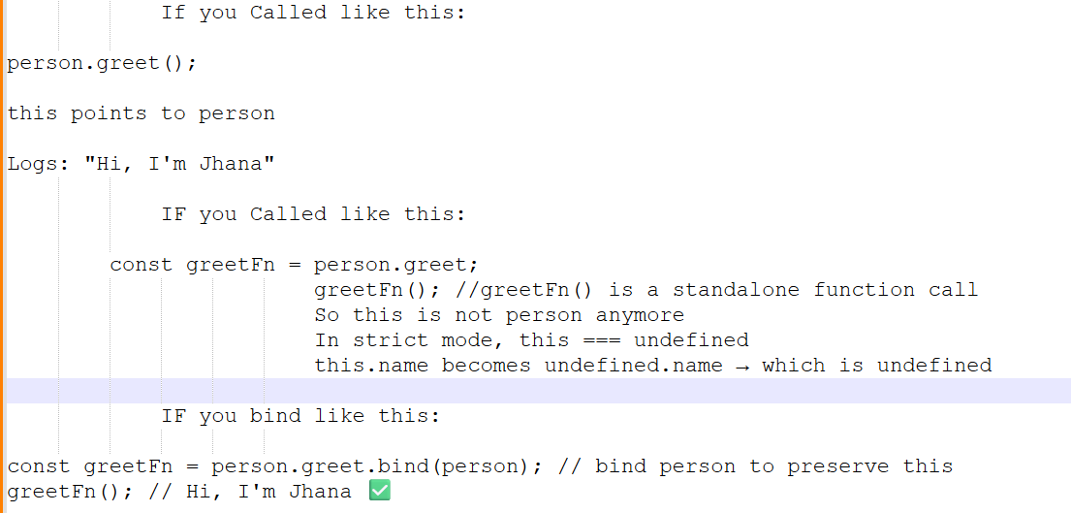
NEXT
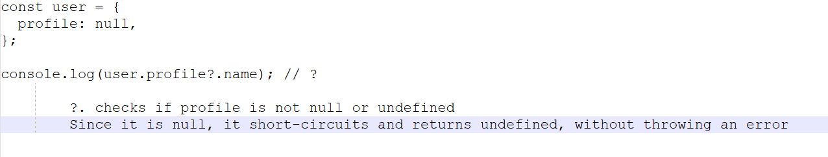
NEXT
greet(); // ❓
var greet = function () {
console.log("Hello!");
}; // it will throw a Type Error because function expression won’t support hoist
NEXT
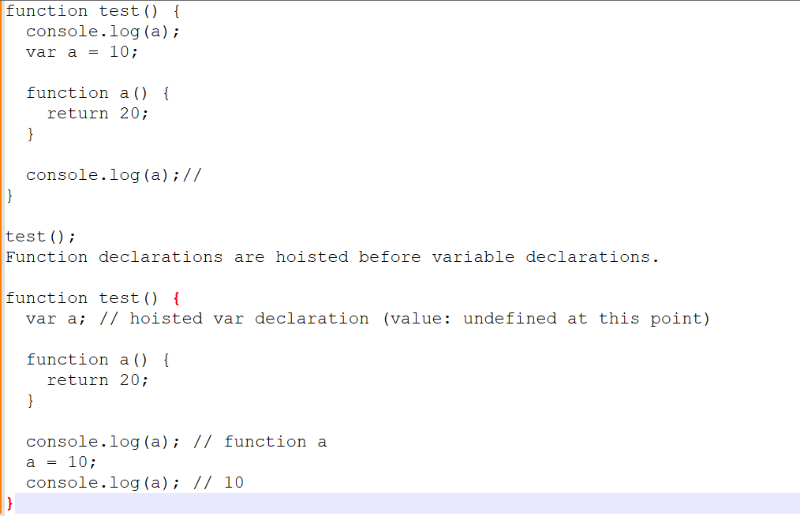
NEXT

let a = [1, 2, 3];
let b = a;
b.push(4);
console.log(a); // [1,2,3,4]
console.log(b); // [1,2,3,4]
object comparison and memory reference
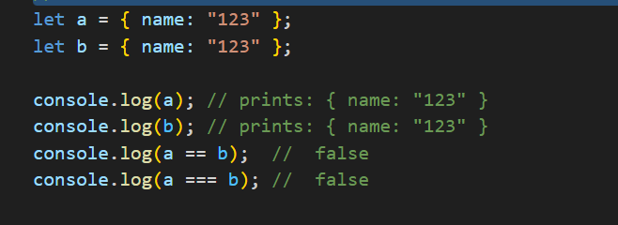
Objects are compared by reference, not by value.
Even if two objects have identical properties and values, if they are created separately, they are stored at different memory locations.
Quick Challenge with object
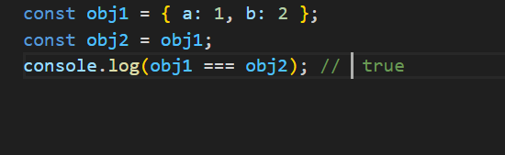
obj2 is not a new object.
It is just a reference to the same object in memory that obj1 points to.
Quick Challenge with array
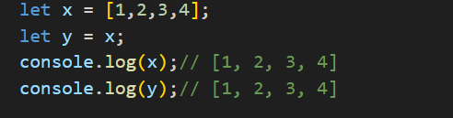
because y is just a reference to the same array x
Need not to change p value.
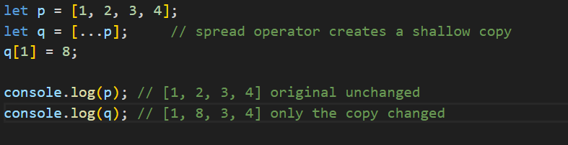
Just recap
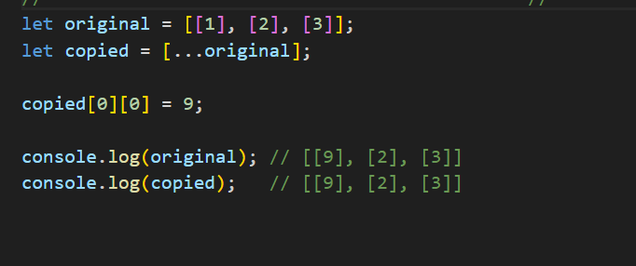
Even though we used the spread operator ([...]) to copy the array, it was a shallow copy, not a deep copy.
copied is a new outer array — ✅ new reference
But each inner element (like [1], [2], [3]) is still a reference to the same inner array in memory
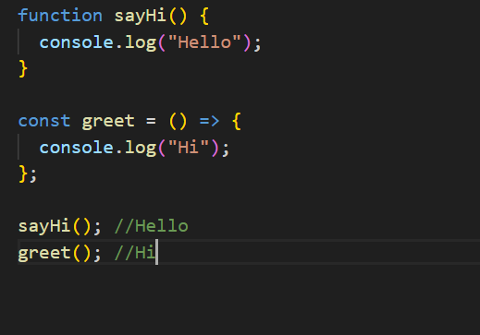
sayHi() is a regular function (hoisted)
greet() is an arrow function (must be declared before calling, and it is)
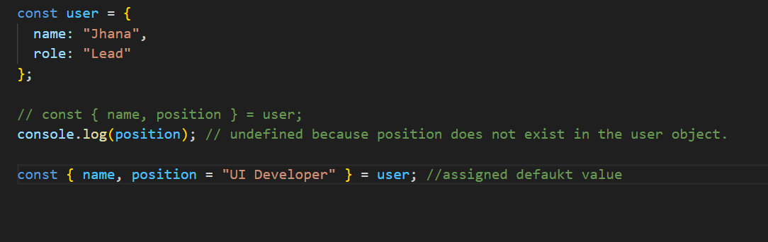
Write a describe User function that takes a user object:
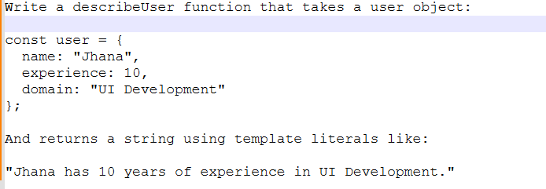
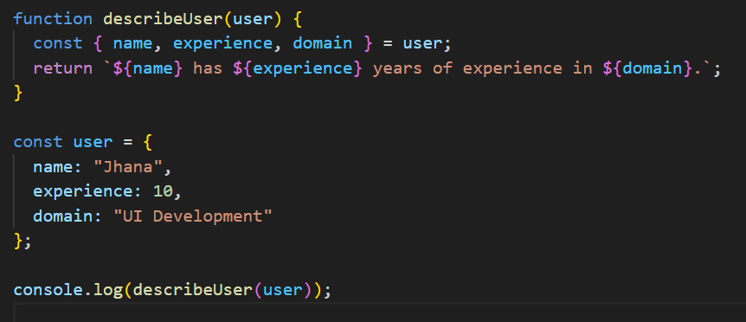
Using Map
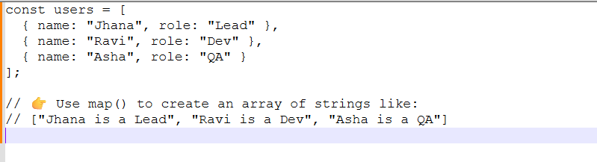
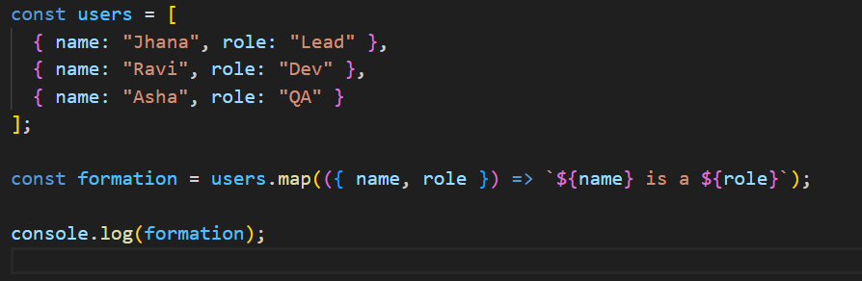
Coding’s with filter concept
